YourName: Shyaan Khan period: 4
Directions: Complete all questions
Single For Loop Explanation and MiniLabs
- *
- Simple For loop Example
- This Java Example shows how to use for loop to iterate in Java program.
- */

- public class SimpleForLoopExample {

- public static void main(String[] args) {

- /* Syntax of for loop is
- *
- * for(<initialization> ; <condition> ; <expression> )
- * <loop body>
- *
- * where initialization usually declares a loop variable, condition is a
- * boolean expression such that if the condition is true, loop body will be
- * executed and after each iteration of loop body, expression is executed which
- * usually increase or decrease loop variable.
- *
- * Initialization is executed only once.
- */

- for(int index = 0; index < 5 ; index++)
- System.out.println("Index is : " + index);

- /*
- * Loop body may contain more than one statement. In that case they should
- * be in the block.
- */

- for(int index=0; index < 5 ; index++)
- {
- System.out.println("Index is : " + index);
- index++;
- }

- /*
- * Please note that in above loop, index is a local variable whose scope
- * is limited to the loop. It can not be referenced from outside the loop.
- */
- }
- }

- /*
- Output would be
- Index is : 0
- Index is : 1
- Index is : 2
- Index is : 3
- Index is : 4
- //output for 2nd for loop
- Index is : 0
- Index is : 2
- Index is : 4
- */

#1 MiniLab: You Try: write in Eclipse using a for loop that prints:
Count is: 1
Count is: 2
Count is: 3
Count is: 4
Count is: 5
Count is: 6
Count is: 7
Count is: 8
Count is: 9
Count is: 10
Paste your code: I NEED TO SEE CODE AND SCREENSHOT OF OUTPUT

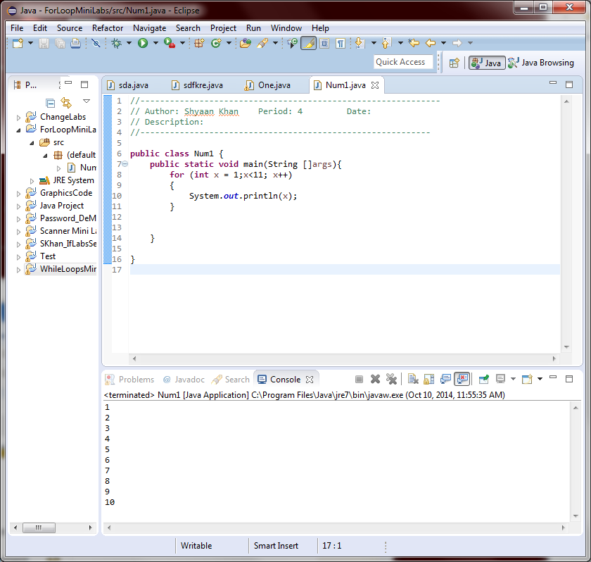
#2:
Now try doing it backwards
count is : 10
count is : 9
count is: 8
etc up to 1
Paste your code: I NEED TO SEE CODE AND SCREENSHOT OF OUTPUT

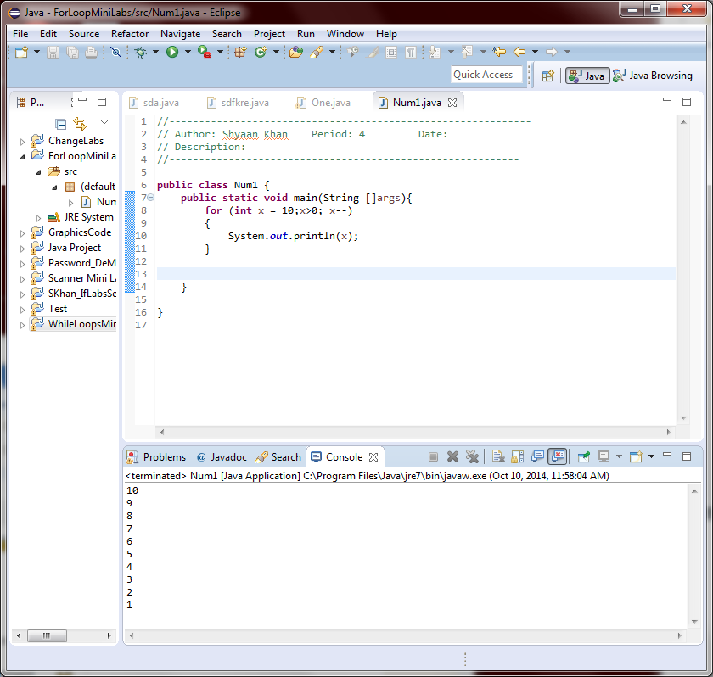

#3: Write a for loop that prints 6 stars ******

Paste your code: I NEED TO SEE CODE AND SCREENSHOT OF OUTPUT
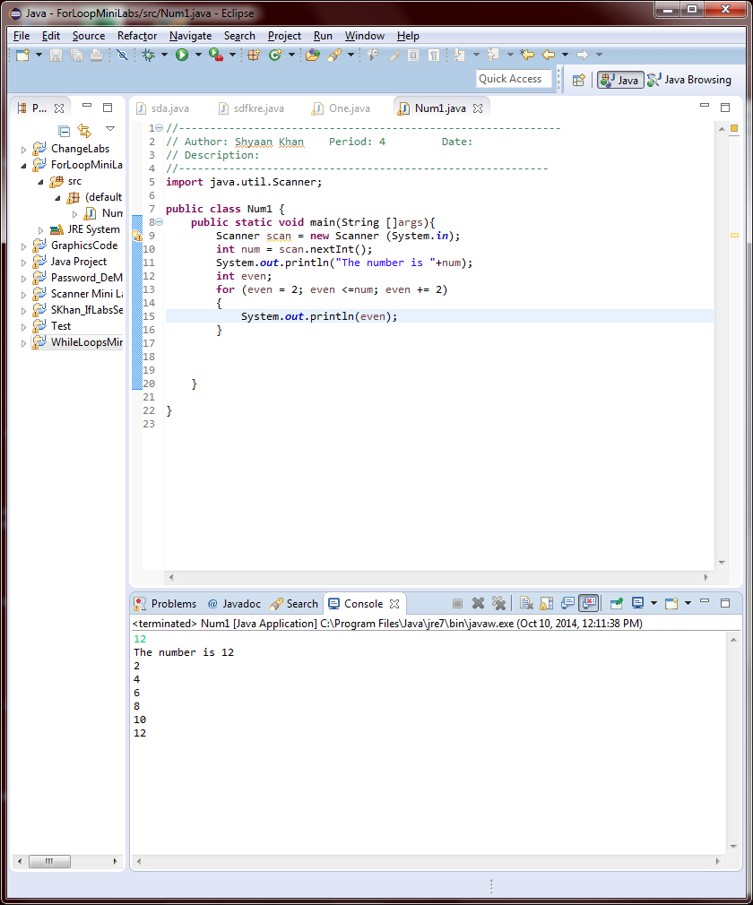

#4: Using a for loop. Ask a user for a number. Print the number given by the user and all the even numbers up to and including the number given.

Paste your code: I NEED TO SEE CODE AND SCREENSHOT OF OUTPUT

#5: Write a for loop to display numbers 1 through 10. I want to have a comma in-between each number like this:
1, 2, 3, 4, 5, 6, 7, 8, 9, 10
I do not want to have commas after last number - NOT LIKE THIS!
1, 2, 3, 4, 5, 6, 7, 8, 9, 10,

Paste your code: I NEED TO SEE CODE AND SCREENSHOT OF OUTPUT

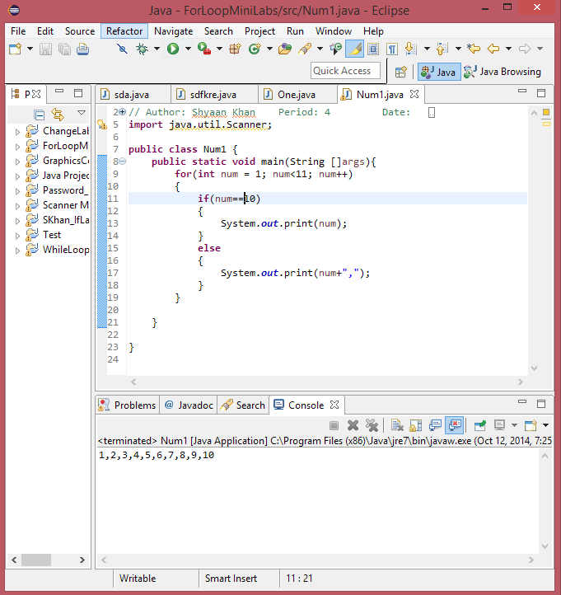

#6: What will the following print? and Why?
int y = 0;
for (int x = 1; x <= 5; x++)
{
y = y + 10;
}
System.out.println(y);
System.out.println(x);

10
5

Because y is the same (y=0) every time the loop runs, and since the print for x is out of the loop, it will print the last loop of x, which is 5 since you add 1 to x until it is less than or equal to 5,

7. What will the following print? and why?
int x;
int y = 0;
for (x = 1; x <= 5; x++)
{
y = y + 10;
}
System.out.println(y);
System.out.println(x);

10
5
Because it is almost identical to the previous code. The only difference is that it is declared out of the for loop, which doesn’t change the output.

8. More Scope: Which statement below is illegal?
int i, j, k;
for (j = 1; j <= 10; j++)
{
k = j; =1, =2
k = i;
i = j; =1
k = i; =1
}

k = i; is illegal.

9. What is the output below of the code fragments with inputs of: 3 6 0 9 -5 2

for (count = 1; count <= 5; count++) count number
{
String input = JOptionPane.showInputDialog("Type a #");
int number = Integer.parseInt(input);
if (number <= 0)
continue;
number = number + 2;
}
System.out.println(number);

}

Input = 3
Output = -5

10) Write a for statement that prints all even numbers from 2 to 100 inclusive. I NEED TO SEE CODE AND SCREENSHOT OF OUTPUT
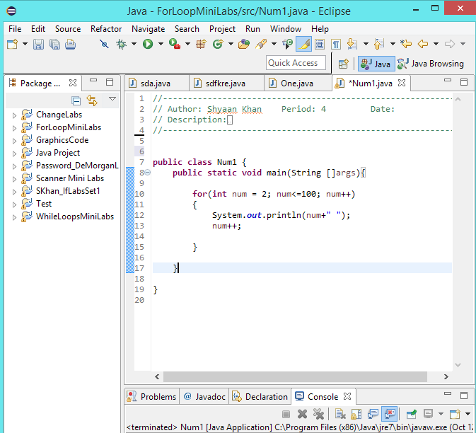
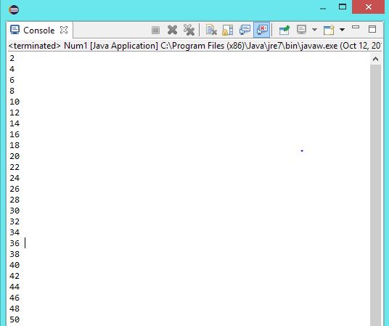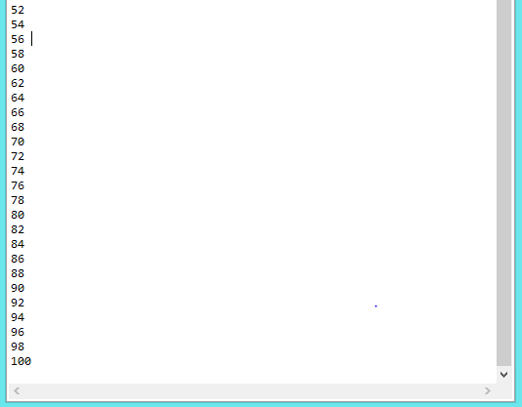
11) Write a for loop that sums the integers from 1 to 50. I NEED TO SEE CODE AND SCREENSHOT OF OUTPUT
